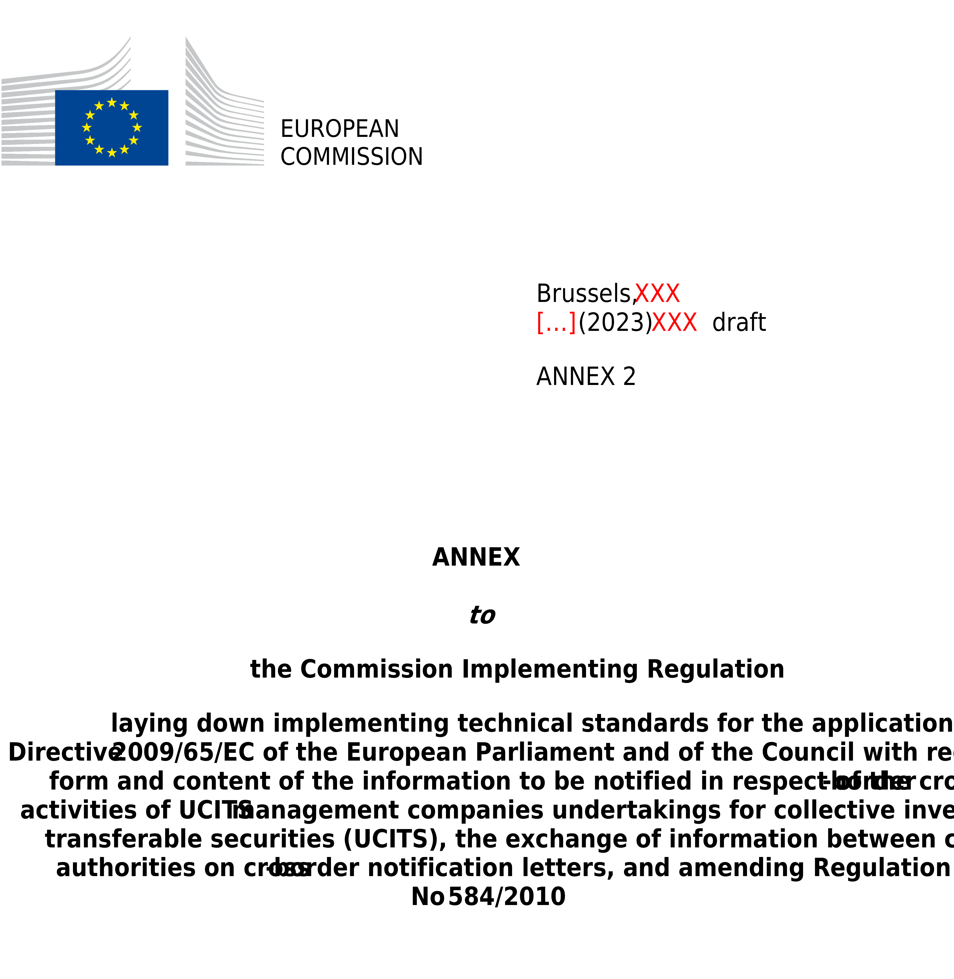

ANNEX II
Model letter to be submitted by a management company to the competent authorities of the UCITS home Member State under Article 20(1) of Directive 2009/65/EC

NOTIFICATION LETTER

NOTIFICATION OF THE INTENTION OF A MANAGEMENT COMPANY TO MANAGE A UCITS ESTABLISHED IN ANOTHER MEMBER STATE IN ACCORDANCE WITH ARTICLE 20(1) OF DIRECTIVE 2009/65/EC.

IN ______________________________________
(The host Member State(s))

Are you notifying amendments to information already provided in an initial notification? Yes ☐ No ☐

If the answer to this question is ‘Yes’, please fill-in only the updated information compared to the previous notification.

Table of contents

PART 1 Information on the management company
PART 2 Identification of the delegate and the delegated functions
PART 3 Attachments

PART 1
Information on the management company

Information on the management company
Management company
Management company’s LEI¹
National identification code of the management company (where available)¹
Management company’s home Member State¹
Address and, where different from address, registered office/domicile
Details of management company’s website

Contact details of the department (or contact point) responsible for application within the management company
Department (or contact point)
Telephone number
Email address

Details of the third party (where the management company designates a third party to make the notification)
Third party
Address and, where different from address, registered office/domicile.
Department (or contact point)
Telephone number
Email address

Contact point for the transmission of the invoice or for the communication of any applicable regulatory fee or charges (if applicable)
Name of the entity
Department (or contact point)
Address and, where different from address, registered office/domicile
Telephone number
E-mail address

Please specify which email address provided in this section (contact point at the management company, contact point within the appointed third party or contact point for the transmission of the invoice) is the preferred address to which the host NCA can transmit any confidential information (inter alia, login and password to access the national systems for reporting)

PART 2
Identification of the delegate and the delegated functions

Please replicate the information in Part 2 for each delegate and delegated functions

Name of the delegate
Delegate’s home Member State
Address and registered office/domicile, where different from address

The delegate will conduct the following activities and provide the following services in the host Member State(s) on behalf of the management company:

☐ Investment management

Administration
☐ Legal and fund management accounting services
☐ Customer inquiries
☐ Valuation and pricing (including tax returns)
☐ Regulatory compliance monitoring
☐ Maintenance of unit-holder register
☐ Distribution of income
☐ Unit issues and redemptions
☐ Contract settlements (including certificate dispatch)
☐ Record keeping

Please describe the reporting line in place between the delegate and the management company

PART 3
Attachments

Written contract with the depositary of the concerned UCITS in the UCITS home Member State.
Other (where applicable, please specify).

_________________________________________________________________________________
(Title of document or name of electronic file attachment)

Note:
The latest versions of the required documents listed above must be attached to this letter for onward transmission by the competent authorities of the management company’s home Member State, even where copies have been provided to that authority previously. Where any of the documents have previously been sent to the competent authorities of the management company’s host Member State and remain valid, the notification letter may refer to that fact.

Provide the link to the latest electronic copies of the attachments

Date
Name and capacity of the signatory
Signature

This field should always be filled-in, also in the case of updates.
Please indicate a single contact point for the transmission of the invoice or for the communication of any applicable regulatory fee or charge referred to in Article 9 of Regulation (EU) 2019/1156 and in Article 2 of Commission Implementing Regulation (EU) 2021/955. That contact point may be the same as the contact point designated within the management company, or a contact point within an appointed third party.

