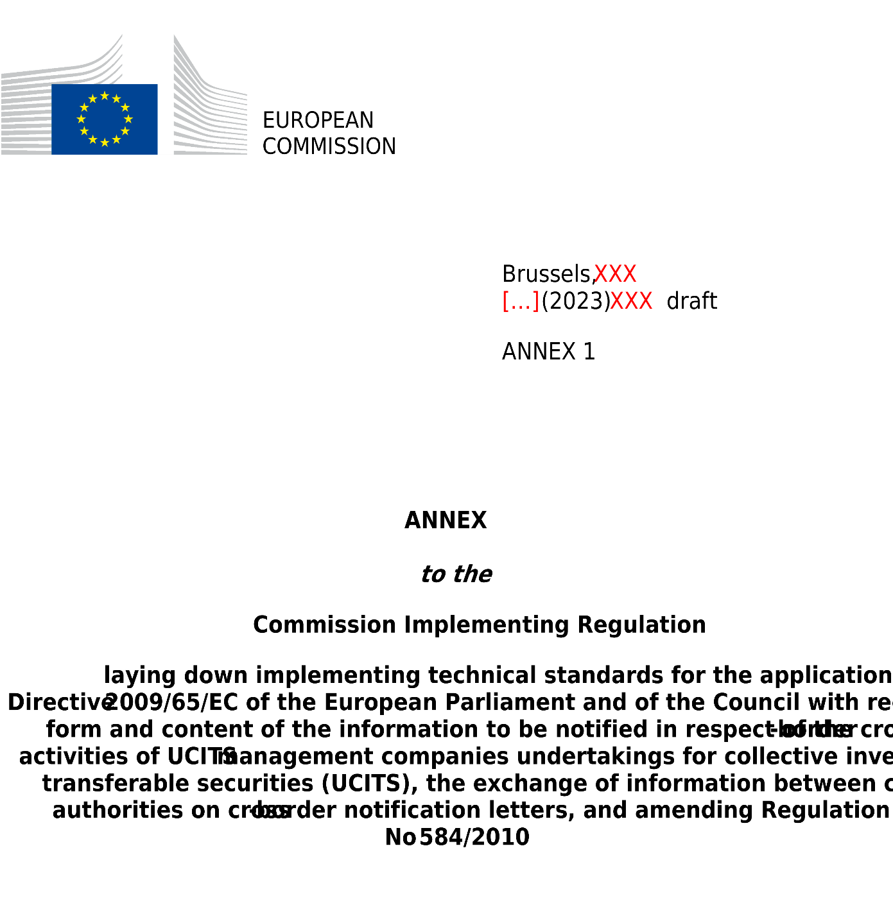

ANNEX I
Model notification letter to be submitted by a UCITS for the cross-border marketing of UCITS under Article 93(1) of Directive 2009/65/EC

NOTIFICATION LETTER

NOTIFICATION OF INTENTION TO MARKET UNITS OF UCITS

IN ______________________________________ (the host Member State)

Are you notifying amendments to information already provided in an initial notification? Yes ☐ No ☐

In case the answer to this question was ‘Yes’, please fill-in only the updated information compared to the previous notification.

Table of contents
PART 1 Information on the management company or internally managed UCITS
Section 1. Identification of the management company or internally managed UCITS
Section 2. Facilities to investors
PART 2 Information on the UCITS
Section 1. Identification of the UCITS
Section 1. Arrangements made for marketing of units of UCITS
Section 2. Attachments
PART 3 Confirmation of completeness

PART 1
Information on the management company or internally managed UCITS

Section 1. Identification of the management company or internally managed UCITS

Information on the management company or internally managed UCITS
Management company or internally managed UCITS
Management company’s or internally managed UCITS’ LEI²
National identification code of the management company or internally managed UCITS (where available)²

Management company’s or internally managed UCITS’ home Member State²

Address and registered office/domicile, where different from address

Details of management company’s or internally managed UCITS’ website

Contact details of the department (or contact point) responsible for notification letter within the management company or internally managed UCITS
Department (or contact point)
Telephone number
Email address

Details of the third party (where a third party is designated by the management company or internally managed UCITS to make the notification)
Third party
Address and, where different from address, registered office/domicile
Department (or contact point)
Telephone number
Email address

Department (or contact point) for the transmission of the invoice or for the communication of any applicable regulatory fee or charges (where applicable)
Name of the entity
Address and, where different from address, registered office/domicile
Department (or contact point)
Telephone number
Email address

Please specify which email address provided in this section (contact point at the management company or internally managed UCITS, contact point within the appointed third party or contact point for the transmission of the invoice) is the preferred address to which the host national competent authority can transmit any confidential information (inter alia, login and password to access the national systems for reporting)

Section 2. Facilities to investors
In accordance with Article 93(1) of Directive 2009/65/EC, please fill-in the following table to provide information on the facilities to perform the tasks referred to in Article 92(1) of that Directive:

Tasks | Information on the facilities performing the tasks | Name/legal form/registered office/address, email, and telephone number for correspondence of the entity responsible to provide the facilities
Process subscription and redemption (or repurchase) orders and make other payments to unitholders relating to the units of the UCITS
Provide investors with information on how orders can be made and how redemption (or repurchase) proceeds are paid
Facilitate the handling of information and access to procedures and arrangements referred to in Article 15 of Directive 2009/65/EC relating to investors’ exercise of their rights
Make the information and documents required pursuant to Chapter IX of Directive 2009/65/EC available to investors
Provide investors with information relevant to the tasks that the facilities perform in a durable medium
Act as a contact point for communicating with the competent authorities

PART 2
Information on the UCITS

Section 1. Identification of the UCITS

Please fill the below table with information for each UCITS you intend to market in the host Member State, creating a new table for each UCITS and by indicating only one share class (name and ISIN) on each line. Where a UCITS takes the form of an umbrella UCITS with several compartments or sub-funds, references to the UCITS in the table below shall be understood as referring to the compartment or sub-fund to be marketed in the host Member State and not to the umbrella UCITS, which shall be identified separately in the corresponding column.

Name of the UCITS to be marketed in the  host Member State | UCITS home Member State | Legal form of the UCITS⁽¹⁾ | LEI of the UCITS (where available) | Name of share class(es) to be marketed in the host Member State⁽²⁾ | ISIN of share class(es) to be marketed in the host Member State⁽²⁾ | Duration of the UCITS (where applicable) | National identification code of the UCITS  (where available) | Name of the umbrella UCITS  (where applicable)

(1) The legal form is one of the following: common fund, unit trust, investment company, or any other legal form available under the national legislation of the UCITS home Member State.
(2) Please list only those share classes the marketing of which is intended.

Section 2. Arrangements made for marketing of units of UCITS

Units of the UCITS/UCITS compartments will be marketed by:

the management company that manages the UCITS or the internally managed UCITS
credit institutions
authorised investment firms or advisers
Other bodies, including bodies located in a third country. Please specify: ___________________

Section 3. Attachments

(1) The latest version of the fund rules or instruments of incorporation, and a translation where required by Article 94(1), point (c), of Directive 2009/65/EC.

_________________________________________________________________________________
(Title of document or name of electronic file attachment)

(2) The latest version of the prospectus, and a translation where required by Article 94(1), point (c), of Directive 2009/65/EC.

_________________________________________________________________________________
(Title of document or name of electronic file attachment)

(3) The latest version of the key investor information, and a translation where required by Article 94(1), point(b), of Directive 2009/65/EC.

_________________________________________________________________________________
(Title of document or name of electronic file attachment)

(4) The latest published annual report and any subsequent half-yearly report, and a translation where required by Article 94(1), point (c), of Directive 2009/65/EC (where available).

_________________________________________________________________________________
(Title of document or name of electronic file attachment)

(5) Where required by the UCITS host Member State, evidence of payment due to the competent authorities of the host Member State

_________________________________________________________________________________
(Title of document or name of electronic file attachment)

Note:
The latest versions of the required documents must be attached to this letter for onward transmission by the competent authorities of the UCITS home Member State, even where copies have been provided to that authority previously. Where any of the documents have previously been sent to the competent authorities of the UCITS host Member State and remain valid, the notification letter may refer to that fact.

Provide the link to the latest electronic copies of the attachments:

_________________________________________________________________________________

PART 3
Confirmation of completeness

Confirmation by the UCITS

We hereby confirm that the documents attached to this notification letter contain all relevant information as provided for in Directive 2009/65/EC.

(The notification letter shall be signed by an authorised signatory of the UCITS, or a third person empowered by a written mandate to act on behalf of the notifying UCITS, in a manner which the competent authorities of the UCITS home Member State accept for certification of documents. The signatory shall state his or her full name and capacity and shall ensure the confirmation is dated.)

Date
Name and capacity of the signatory
Signature

Please fill-in one notification letter for each Member State where the marketing of UCITS is intended.
This field should always be filled-in, also in the case of updates.
Please indicate a single contact for the transmission of the invoice or for the communication of any applicable regulatory fee or charge referred to in Article 9 of Regulation (EU) 2019/1156 and in Article 2 of Commission Implementing Regulation (EU) 2021/955. This contact point may be the same as the contact point designated within the management company, or a contact point within an appointed third party.

