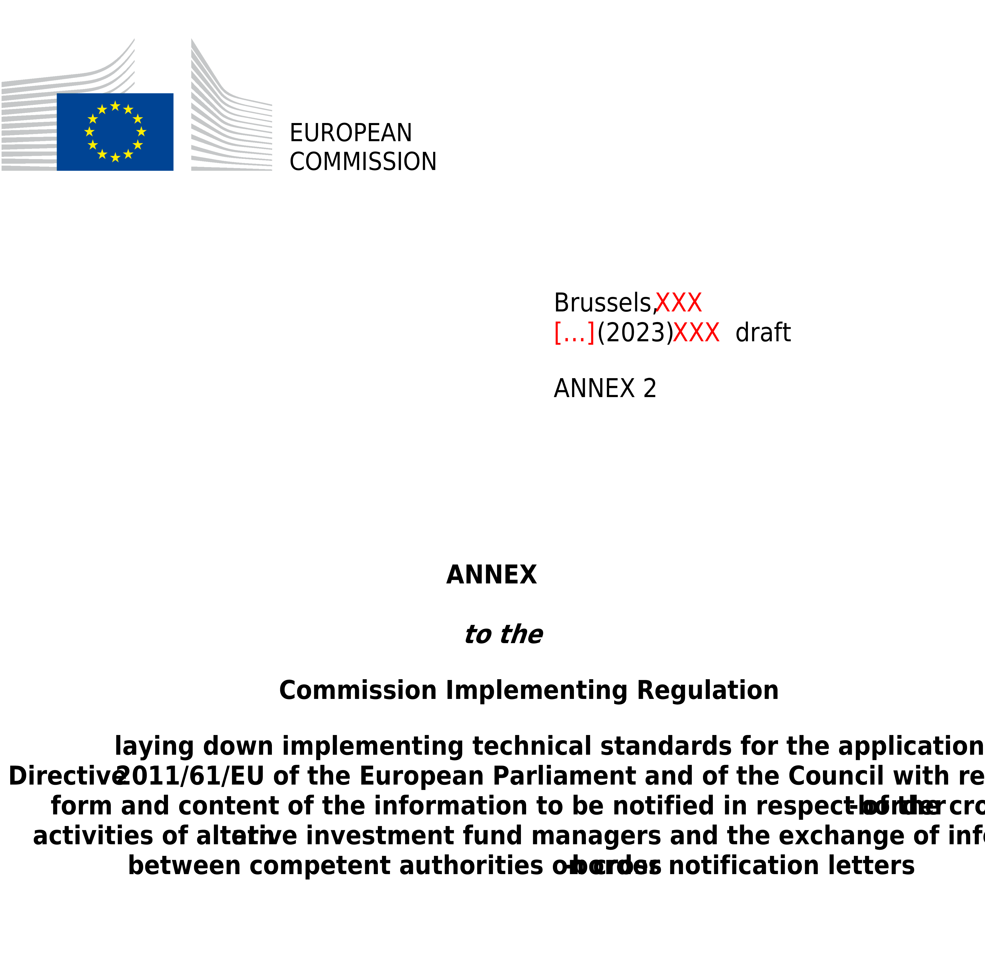

ANNEX II
Model notification letter for the cross-border marketing of EU AIFs under Article 32(2) of Directive 2011/61/EU

NOTIFICATION LETTER

NOTIFICATION OF THE INTENTION TO MARKET UNITS OR SHARES OF AN AIF OR AIFs MANAGED BY THE SAME AIFM IN A MEMBER STATE OTHER THAN THE HOME MEMBER STATE OF THE AIFM IN ACCORDANCE WITH ARTICLE 32(2) OF DIRECTIVE 2011/61/EU (AIFMD).

IN ______________________________________
(The host Member State(s))

Are you notifying amendments to information already provided in an initial notification? Yes No
If the answer to this question is ‘Yes’, please fill-in only the updated information compared to the previous notification.

Table of contents

PART 1 Information on the AIFM or internally managed AIF
Section 1. Identification of the AIFM or internally managed AIF
Section 2. Facilities to retail investors (if relevant)
PART 2 Information on the AIFs to be marketed in the host Member State
Section 1. Identification of the AIFs
Section 2. Arrangements made for marketing of units or shares of AIFs
Section 3. Attachments

PART 1
Information on the AIFM or internally managed AIF

Section 1. Identification of the AIFM or internally managed AIF
Information on the AIFM or internally managed AIF
AIFM or internally managed AIF
AIFM or internally managed AIF LEI²
National identification code of the AIFM or internally managed AIF (where available)²
AIFM’s or internally managed AIF’s home Member State²
Address and, where different from address, registered office/domicile
Duration of the AIFM or internally managed AIF, where applicable
Details of AIFM’s or internally managed AIF’s website

Contact details of the department (or contact point) responsible for the establishment of the notification letter within the AIFM or internally managed AIF
Department (or contact point)
Telephone number
Email address

Details of the third party (where the AIFM or internally managed AIF designates a third party to make the notification)
Third party
Address and, where different from address, registered office/domicile
Department (or contact point)
Telephone number
Email address

Contact point for the transmission of the invoice or for the communication of any applicable regulatory fee or charges (if applicable)
Name of the entity
Address and, where different from address, registered office / domicile
Department (or contact point)
Telephone number
Email address

Please specify which email address provided in this section (contact point at the AIFM or internally managed AIF, contact point within the appointed third party or contact point for the transmission of the invoice) is the preferred address to which the host NCA can transmit any confidential information (inter alia, login and password to access the national systems for reporting)

Section 2. Facilities to retail investors (where relevant)
Pursuant to Article 32(1) of Directive 2011/61/EU, EU AIFMs are authorised to market units or shares of EU AIFs they manage to professional investors in other Member States than their home Member State. However, Member States may allow AIFMs to market to retail investors in their territory units or shares of AIFs they manage in accordance with Article 43 of Directive 2011/61/EU.

The information on facilities to retail investors must be filled in case marketing of the AIFs targets retail investors.

In accordance with point (j) of Annex IV of Directive 2011/61/EU, please fill-in the following table to provide information on the facilities to perform the tasks referred to in Article 43a(1) of this Directive:

Task of the facility | Information on the facilities performing the tasks | Name/legal form/registered office/ address, email, and telephone number for correspondence of the entity responsible to provide the facilities
Process investor’s subscription, payment, and redemption (or repurchase) orders relating to the units or shares of the AIF
Provide investors with information on how orders referred to above can be made and how redemption (or repurchase) proceeds are paid
Facilitate the handling of information relating to the exercise of investor’s rights arising from their investment in the AIF
Make the information and documents required pursuant to Articles 22 and 23 of Directive 2011/61/EU available to investors for the purposes of inspection and obtaining copies thereof
Provide investors with information relevant to the tasks that the facilities perform in a durable medium as defined in Article 43a(1)(e) of Directive 2011/61/EU.
Act as a contact point for communicating with the competent authorities

PART 2
Information on the AIFs to be marketed in the host Member State
Section 1. Identification of the AIFs

Please fill the table below with information for each AIF you intend to market in the host Member State, creating a new table for each AIF and by indicating only one share class (name and ISIN) on each line. Where an AIF takes the form of an umbrella AIF with several compartments or sub-funds, references to the AIF in the table below shall be understood as referring to the compartment or sub-fund to be marketed in the host Member State and not to the umbrella AIF, which shall be identified separately in the corresponding column.

Name of the AIF to be marketed in the host Member State | Date of incorporation or constitution of the AIF | AIF’s home Member State | Legal form of the AIF⁽¹⁾ | LEI of the AIF  (where available) | Marketing to retail investors⁽²⁾ | Name of each share class of the AIF | ISIN of the AIF / of each share class of the AIF  (where available) | Name of the depositary of the AIF | Duration of the AIF  (where applicable) | AIF national identification code  (where available) | Name of the umbrella AIF  (where applicable) | AIF’s investment strategy⁽³⁾

(1) The legal form is one of the following: common fund, unit trust, investment company, or any other legal form available under the national legislation of the AIF home Member State.
(2) Where allowed in the home Member State of the AIFM: ‘Yes’/’No’. Where legislation of the home Member State of the AIFM does not allow marketing to retail investors, please indicate ‘N/A’.
(3) Please specify the predominant AIF type and the breakdown by investment strategies as set out in the reporting template included in Annex IV of Commission Delegated Regulation (EU) 231/2013.

Master-feeder structures (if applicable):
Name of the master AIF or compartment(s) | LEI of master AIF or compartment(s) (where available) | AIFM of the master AIF / compartment (where different from the AIF’s AIFM) | LEI of the AIFM of the master AIF / compartment (where different from the AIF’s AIFM and where available) | Home Member State of the master AIF (where different from the AIF’s home Member State) | Home Member State of the AIFM (where different from the master AIF’s home Member State)

Section 2. Arrangements made for marketing of units or shares of AIFs
Units or shares of the AIF/AIF compartments will be marketed by:

the AIFM that manages the AIF or the internally managed AIF
credit institutions
authorised investment firms or advisers
Other bodies, including bodies located in a third country. Please specify: ___________________

Please provide information on the arrangements established to prevent units or shares of the AIF from being marketed to retail investors, including in the case where the AIFM relies on activities of independent entities to provide investment services in respect of the AIF

Section 3. Attachments
The latest version of the AIF rules or instruments of incorporation.
The latest version of the offering document (e.g., prospectus).
The AIF’s latest annual report (if available).
Any additional information referred to in Article 23(1) of Directive 2011/61/EU for each AIF to be marketed (Paragraph (f) of Annex IV).
Other (please specify).

_________________________________________________________________________________
(Title of document or name of electronic file attachment)

Date
Name and capacity of the signatory
Signature

This notification letter should also be used for AIF that also qualify as European Long Term Investment Fund and are marketed under Article 31(2) of Regulation (EU) 2015/760 in conjunction with Article 32(2) of Directive 2011/61/EU.
This field should always be filled-in, also in the case of updates.
Please indicate a single contact point for the transmission of the invoice or for the communication of any applicable regulatory fee or charge referred to in Article 9 of Regulation (EU) 2019/1156 and in Article 2 of Commission Implementing Regulation (EU) 2021/955. That contact point may be the same as the contact point designated within the AIFM, or a contact point within an appointed third party.
This information must be filled only in respect of the AIFs the marketing of which is envisaged to professional investors only. No arrangements need to be put in place in respect of AIFs that the AIFM/self-managed AIF intends to market to retail investors, where permitted by the national legislation of the home Member State of the AIFM in accordance with Article 43 of Directive 2011/61/EU. In case this notification letter refers to both AIFs targeting professional investors and AIFs targeting retail investors, please indicate information only in respect of AIFs targeting only professional investors.

